This document reviews the new changes/request for the producer dashboard.

# Dashboard – dashboard.html

Created with clients, servicing team, activity, and total claims sections.

**Display all**The dropdown options are dropdowns for the producers clients. Once selected, the entire dashboard should change based on the selected company. For right now, we’ll only be using the parent of the companies.



1. **Clients**

The numbers represent the total number of the values in the system.  
When you click “25” it takes you to the search results of all of the clients for that producer.

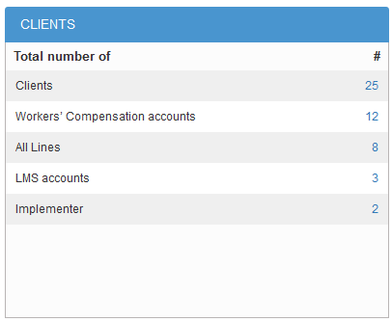

1. **Servicing Team – (rest servicing team gets displayed on servicing-team.html)**

Displays the first **3** accounts that the claims/risk advocates are serving. When a number is clicked, you are then taken to the client screen filtered by the risk/claims advocate.

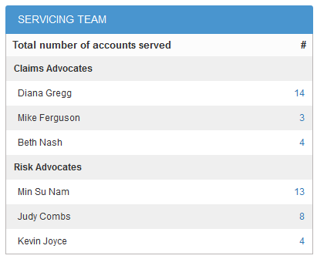

1. **Activity**

Displays triggers and journal entries open and closed. Filtered by date opened. The type of journal entry being display is any journal entry entered by an IOA representative (Fred, Amy, or Claims Advocate)

The dropdown default filtered is by the month.

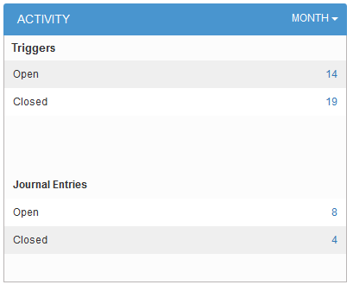

1. **Total Claims**

Updated style of current dashboard that is display for internal/admin users. Display all is a filter, that once selected changes the graphs/charts.

